**SPRINT 3**

|  |  |
| --- | --- |
| **TEAM ID** | PNT2022TMID15063 |
| **PROJECT NAME** | Gas leakage monitoring and alerting system for industries |

**GENERATING API KEY FOR NODE RED COMMUNICATION**

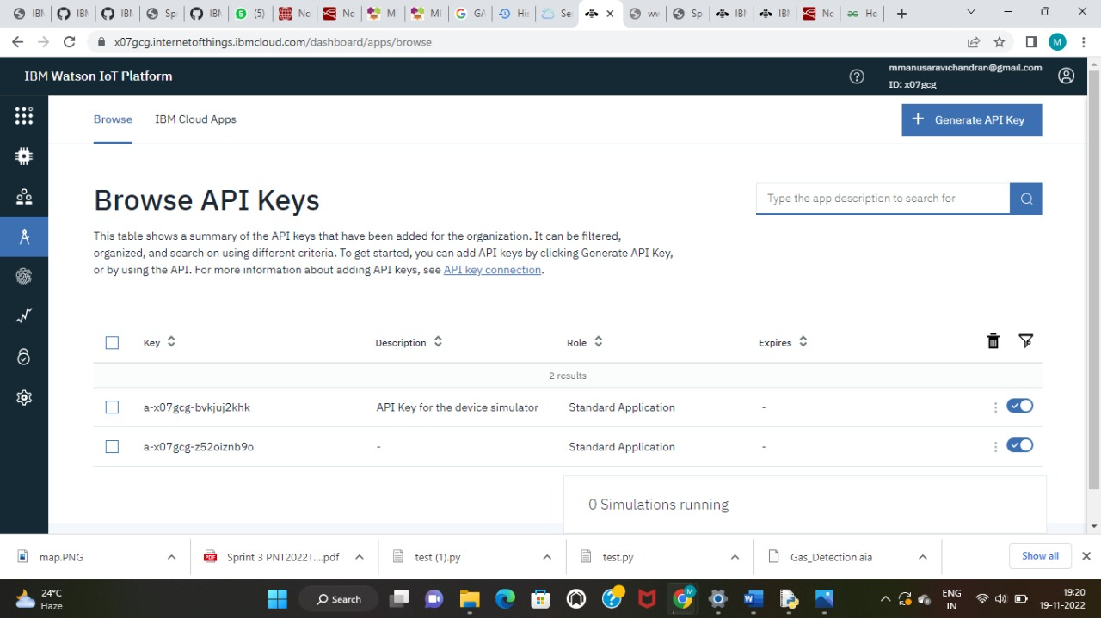

**Creating API keys for comunication with node red**

**FUNCTIONS CREATED IN NODE RED FOR PROCESSING**

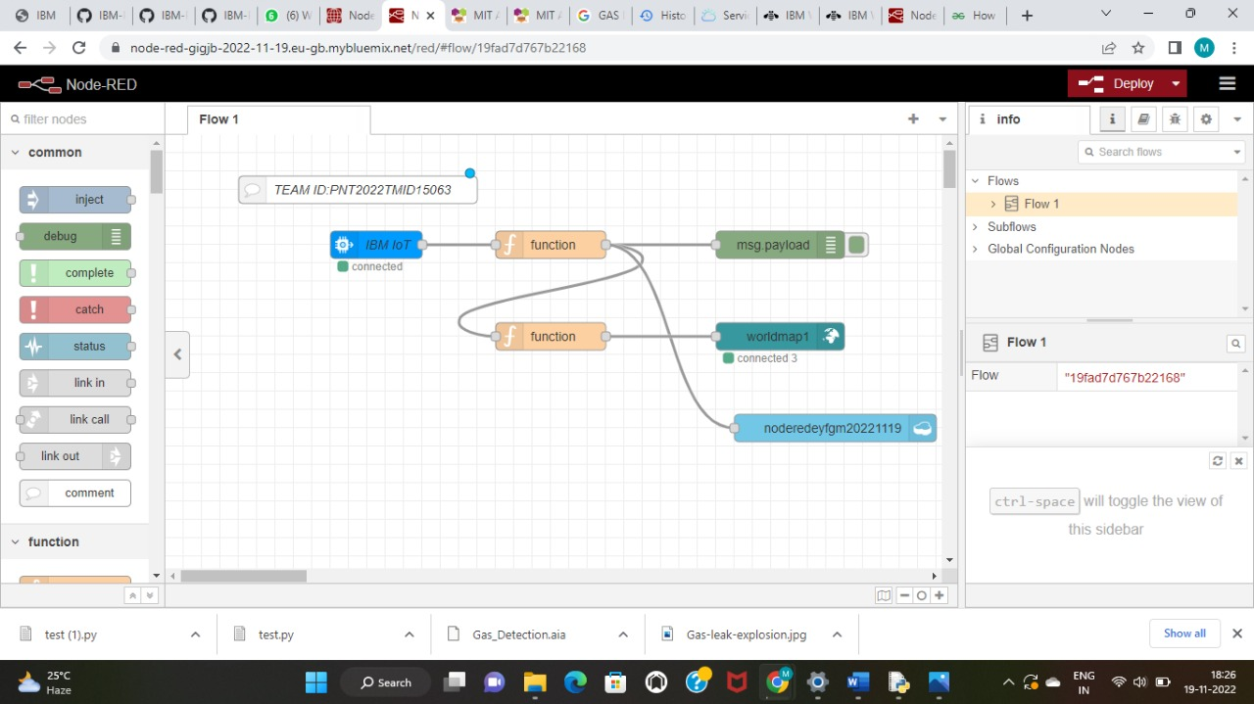

**Creating functions in node red**

**ACCESSING DASHBOARD AND SETTING PARAMETERS FOR CHARTS**

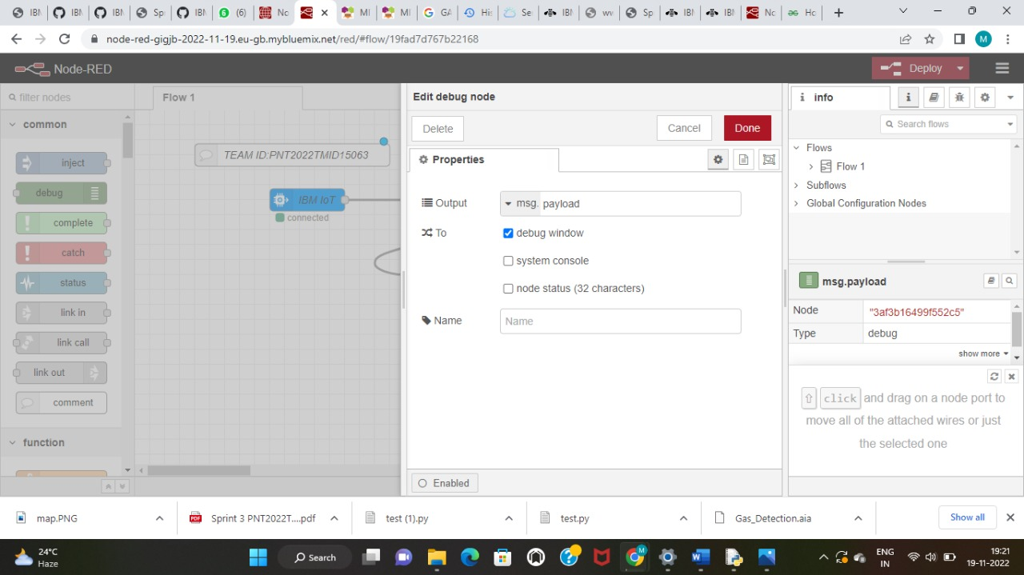

**Dashboard creation in node red**

**Dashboard values display**

**DISPLAYING LATITUDAL AND LONGITUDINAL VALUES IN THE WEB PAGE**

